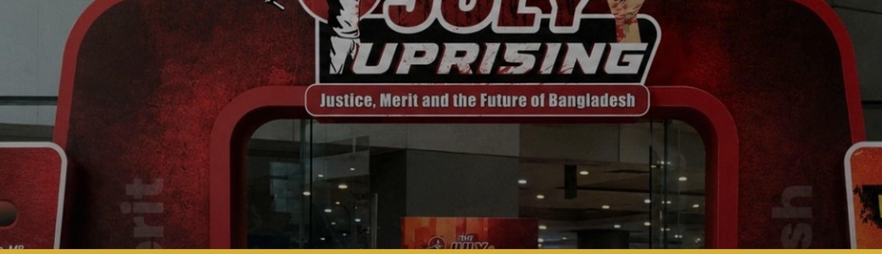
EVENT 09 | 36TH JULY CELEBRATION 2026
JULY MEMOIR PUBLICATION 2026
A Premium Print and Digital Archive for Future Generations

DATE | Official unveiling: 9 August 2026 | TIME | Submission before 16 July 2026
VENUE | Online submission; launched at Shaheed Abu Sayed International Convention Center, Shahbagh, Dhaka | MODE | Editorial submission, print publication and digital archive
REGISTRATION | FREE | OFFICIAL PORTAL | ndfbd.org/july

EVENT OVERVIEW

A premium commemorative publication bringing together memoirs, testimonies, academic materials, interviews, poetry, photography, artwork, conference abstracts and QR-linked multimedia documentation. It will connect personal memory with credible research, ethical editing and long-term national archiving.
Memoirs and Testimonies  First-person accounts from healthcare professionals, families, witnesses, injured participants and volunteers. | Academic and Policy Writing  Research, conference papers, public-health reflections and institutional lessons.
Literature and Creative Work  Essays, poetry, visual narratives, artwork and carefully edited storytelling. | Photography and Archive  Captioned photographs, documents and visual evidence with proper consent and source information.
Print and Digital Editions  Professionally edited publication with a searchable digital version where approved. | QR-Linked Multimedia  Connections to documentaries, interviews, speeches and selected digital archive materials.

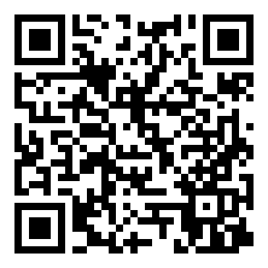 | FREE REGISTRATION  Register online: https://ndfbd.org/july  National Doctors Forum (NDF) | 01624-262148 | nationaldoctorsforum@gmail.com

1. PURPOSE AND STRATEGIC OBJECTIVES

The publication will preserve diverse forms of memory in a credible, readable and internationally presentable format for researchers, families, institutions and future generations.
- Document personal, professional and public experiences of July.
- Publish credible academic, humanitarian, literary and visual contributions.
- Preserve consented photographs, interviews, documents and multimedia links.
- Create a bilingual or accessible publication framework for national and international readers.
- Support long-term archiving, education, research and public remembrance.

2. PROGRAMME FORMAT AND KEY COMPONENTS

COMPONENT | DETAILS
Category-Based Submission | Memoir, essay, research, policy analysis, poetry, interview, photo story, artwork or archival document.
Editorial Screening | Relevance, originality, factual integrity, consent and fit with the publication plan.
Fact-Checking and Ethics Review | Verification of names, dates, claims, captions, sensitive content and permissions.
Copyediting and Revision | Language, structure, references, style consistency and author-approved revisions.
Design and Production | Print layout, digital edition, image preparation, captions and QR-link integration.
Launch and Distribution | Official unveiling, contributor acknowledgement and planned print/digital circulation.

3. ELIGIBILITY

Writers, researchers, healthcare professionals, students, witnesses, martyr families, injured participants, journalists, photographers, artists and citizens with relevant original work may submit. Contributors may submit in Bangla or English according to category instructions.
4. HOW TO PARTICIPATE

1 | Register under “July Memoir Publication” at https://ndfbd.org/july.
2 | Select the submission category and upload an editable manuscript or high-resolution visual file.
3 | Include title, author profile, affiliation, contact, references, captions, permissions and disclosure of prior publication.
4 | Respond to editorial queries and submit revisions within the communicated timeline.
5 | Review the final proof when requested and approve factual details before publication.

ENTRY / SUBMISSION REQUIREMENTS
Submissions must be original, factual, ethically prepared and free of plagiarism. Academic articles may follow the conference limit of up to 8,000 words where applicable; abstracts are generally 250-300 words with 3-5 keywords. Category-specific word limits will be published separately. Sensitive stories and images require informed consent and may be anonymised.

5. RULES, ETHICS AND CODE OF CONDUCT

- Submission is free.
- The Editorial Board may copyedit, fact-check, translate, shorten or request revision while preserving the author's meaning.
- Unverified allegations, fabricated quotations, unauthorised images and defamatory content will be rejected.
- Authors must disclose conflicts of interest, prior publication and AI-assisted drafting or translation where relevant.
- Final publication depends on editorial quality, available space, legal review and author cooperation.
6. SELECTION OR EVALUATION FRAMEWORK

CRITERION | WHAT THE REVIEW PANEL WILL CONSIDER
Relevance and Contribution | Clear value to historical memory, healthcare learning, policy, literature or humanitarian documentation.
Originality and Voice | Authentic perspective, distinctive insight and meaningful contribution.
Factual Accuracy | Verifiable names, dates, events, references, captions and context.
Writing or Visual Quality | Clarity, structure, readability, image quality and editorial readiness.
Ethics and Permissions | Consent, privacy, copyright, attribution and responsible treatment of sensitive material.

7. SCHEDULE, ACCESS AND PARTICIPANT SUPPORT

- Editable templates, style guidance, citation format and image specifications will be published online.
- Authors may be contacted for verification, consent documents, translation or revision.
- The Editorial Board will manage copyediting, proofing, design and final publication sequence.
- Launch date is fixed for the main event; submission and proof deadlines will be announced separately.
IMPORTANT NOTICE
Final category limits, editorial selection, translation, print quantity, complimentary copies and publication rights are subject to Editorial Board and Organizing Committee approval.

FREE REGISTRATION
Register online: https://ndfbd.org/july
National Doctors Forum (NDF) | 01624-262148 | nationaldoctorsforum@gmail.com

