EVENT 03 | 36TH JULY CELEBRATION 2026
SHAHEED ALI RAYHAN CULTURAL PROGRAMME
A Dignified Cultural Tribute of Remembrance, Unity and Hope

DATE | 9 August 2026 (Sunday) | TIME | 7:00 PM - 10:00 PM
VENUE | Shaheed Abu Sayed International Convention Centre, Shahbagh, Dhaka | MODE | On-site cultural and commemorative evening
REGISTRATION | Category-wise / Open to registered participants | OFFICIAL PORTAL | https://ndfbd.org/july

1. EVENT OVERVIEW
The principal cultural evening of the 36th July Celebration will transform memory, sacrifice and the aspirations of July into a respectful artistic experience. The programme is planned as a national tribute rather than conventional entertainment, combining music, recitation, theatre, visual storytelling and recognition.
Patriotic and Values-Based Music  Selected songs and ensemble performances centred on courage, service, justice and national unity. | Recitation and Spoken Word  Poetry, narrative and spoken-word pieces presented with dignity and historical sensitivity.
Theatre and Visual Storytelling  Short dramatic presentations that communicate sacrifice, healthcare service and hope. | Documentary and Content Showcase  Selected documentary or content-competition work may be screened during the evening sequence.
Honouring and Prize Giving  Recognition of martyr families, healthcare heroes, competition winners and selected contributors. | Grand Closing Tribute  A coordinated closing performance carrying a message of unity, dignity and future commitment.

 | REGISTRATION  Register online: https://ndfbd.org/july  National Doctors Forum (NDF) | 01624-262148 | nationaldoctorsforum@gmail.com

2. PURPOSE AND STRATEGIC OBJECTIVES
The programme will use culture as a responsible language of remembrance, bringing families and communities together without sensationalising trauma or sacrifice.
● Offer a dignified stage for patriotic, Islamic, literary, theatrical and visual cultural expression.
● Honour martyr families, injured participants, healthcare professionals and humanitarian contributors.
● Promote national unity, justice, compassion and responsible citizenship.
● Engage young performers and cultural teams in high-quality, theme-aligned work.
● Create professionally recorded cultural material for the official NDF archive and future documentation.
3. PROGRAMME FORMAT AND KEY COMPONENTS
COMPONENT | DETAILS
Opening Tribute | A short curated opening with recitation, remembrance and the official theme.
Music and Ensemble Segment | Patriotic songs, Islamic cultural presentations and approved group performances.
Poetry and Spoken Word | Selected recitation, storytelling and original spoken-word work.
Drama and Visual Narrative | Short theatrical or multimedia pieces based on verified stories and approved scripts.
Recognition Segment | Souvenir unveiling, prize giving, selected speeches and honouring of contributors or families.
Closing Performance | A coordinated finale reflecting justice, unity, healing and future commitment.
4. ELIGIBILITY AND ACCESS
Registered participants, invited guests, families, healthcare professionals, students, media and civil society may attend, subject to venue capacity and registration rules. Individual performers, institutions and cultural teams may apply for selection by submitting a synopsis, performer list and technical requirements.
Registration Fee Structure
PARTICIPANT CATEGORY | REGISTRATION FEE
Student | BDT 100
Intern Doctor | BDT 300
Trainee / Resident | BDT 500
Assistant Professor / Consultant | BDT 1,000
Associate Professor | BDT 1,500
Professor and Above | BDT 2,000
5. HOW TO PARTICIPATE
1 | Complete general audience registration or choose the Cultural Team option at https://ndfbd.org/july.
2 | For performance consideration, submit the title, category, synopsis, duration, performer list and contact person.
3 | Upload or share a rehearsal video, script, lyrics, backing-track details or visual plan when requested.
4 | Attend the screening, briefing, rehearsal and sound-check scheduled by the Cultural Programme Committee.
5 | Perform only the approved version and follow stage, timing, costume, sound and media instructions.
7. ENTRY / SUBMISSION REQUIREMENTS
Content Approval and Production Requirements
All scripts, lyrics, visuals, costumes, backing tracks and copyrighted material may be reviewed before approval. Content must be family-friendly, respectful, historically sensitive and consistent with the official theme. Performers are responsible for securing permissions for copyrighted music, images or footage. The committee may request revisions to protect programme dignity, timing and technical quality.

8. RULES, ETHICS AND CODE OF CONDUCT
● Audience and performer registration are subject to confirmation and venue capacity.
● No unapproved political slogan, defamatory content, graphic imagery, commercial promotion or unsafe stage act is permitted.
● The Cultural Programme Committee may edit sequence, duration, staging and technical requirements to protect programme quality.
● Performers must report on time for rehearsal, sound check and backstage coordination.
● Recording and media use will follow the consent stated in the registration process.
9. SELECTION AND EVALUATION FRAMEWORK
CRITERION | WHAT THE REVIEW PANEL WILL CONSIDER
Theme Alignment | Meaningful connection with remembrance, justice, humanitarian service, unity and hope.
Artistic Quality | Performance skill, composition, direction, voice, movement or production value.
Originality | Fresh interpretation, creative structure and authentic artistic voice.
Dignity and Sensitivity | Respect for families, witnesses, audiences and the historical context.
Stage Readiness | Timing, discipline, rehearsal quality, technical feasibility and teamwork.
10. SCHEDULE, ACCESS AND PARTICIPANT SUPPORT
● Selected teams will receive a technical checklist and rehearsal schedule.
● Available sound, projection, microphone and stage support will be confirmed after selection.
● Final running order, reporting time and duration will be communicated to approved performers.
● The venue will maintain first aid, security, controlled backstage access and family seating guidance.
● Media documentation and archival recording will be coordinated through the official media team.
Important Notice
The Organizing Authority reserves the right to revise, modify, postpone, cancel, or make any necessary decision regarding the programme, if circumstances require. Final performance selection, sequence, duration, prize values and recording permissions will be determined by the Cultural Programme Committee. Submission does not guarantee stage approval.

REGISTRATION
Register online: https://ndfbd.org/july
National Doctors Forum (NDF) | 01624-262148 | nationaldoctorsforum@gmail.com

11. CULTURAL FEST SUB-COMMITTEE
NAME | ROLE | CONTACT
Dr. Sujan Sharif | Convener | 01712-423410
Dr. Abdur Nur Sayem | Member | 01743-621053
Dr. Mukhlesur Rahman | Member | 01741-201190
Dr. Shahabuddin Raju | Member | 01749-526860
Dr. Ali Ajgar | Member | 01753-444667
OFFICIAL FLYER / VISUAL REFERENCE
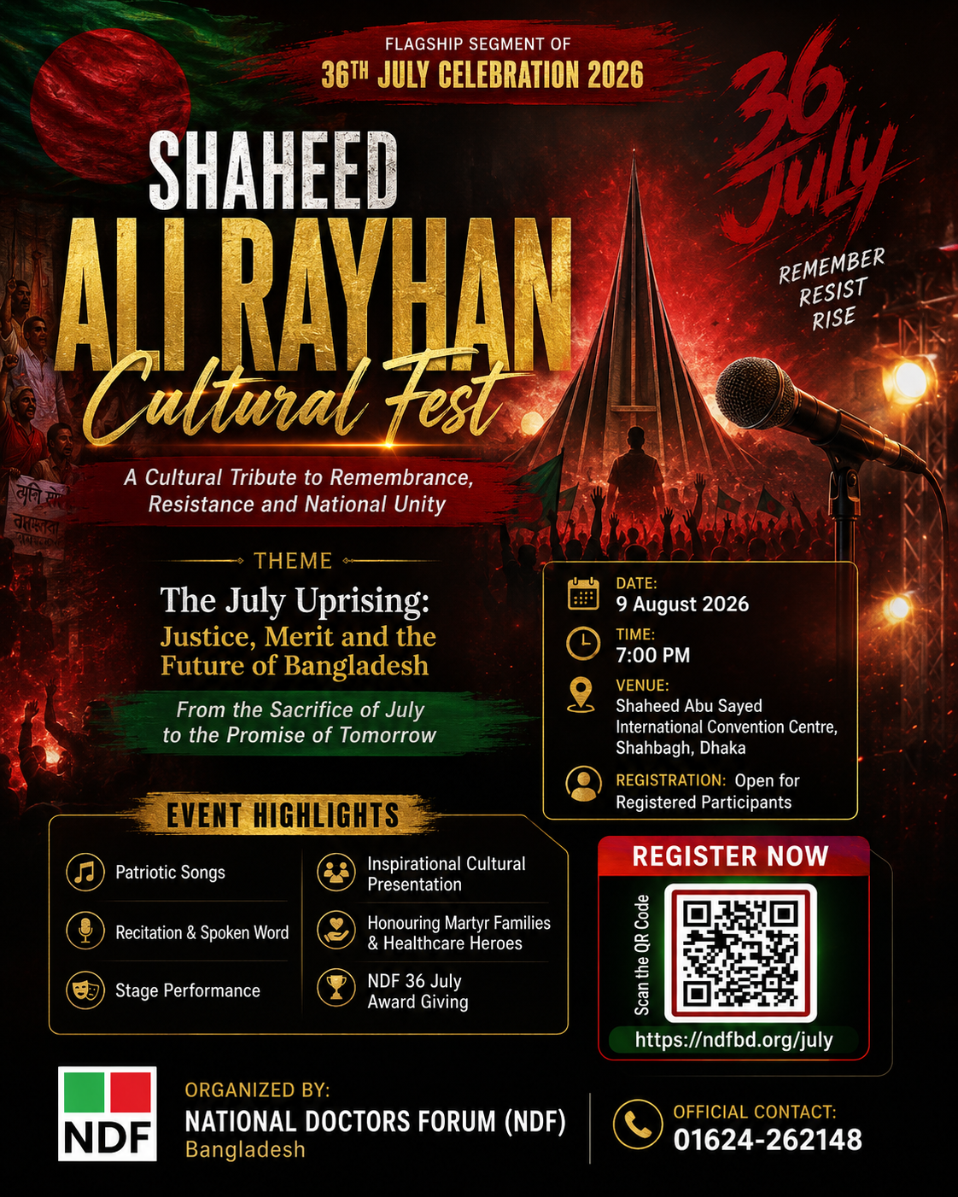
Note: Final print-ready artwork, logo placement and QR visibility should be verified by the design team before mass printing.

