EVENT 01 | 36TH JULY CELEBRATION 2026
JULY MEDICAL CONFERENCE 2026
The Role of Healthcare Professionals in the July Movement 2024 in Bangladesh
DATE | 9 August 2026 (Sunday) | TIME | 2:00 PM - 5:00 PM
VENUE | Shaheed Abu Sayed International Convention Centre, Shahbagh, Dhaka | MODE | On-site academic conference with publication track
REGISTRATION | Free | OFFICIAL PORTAL | https://ndfbd.org/july
1. EVENT OVERVIEW
The July Medical Conference 2026 is the flagship academic platform of the 36th July Celebration. It will document, analyse and honour the contribution of healthcare professionals during the July Movement 2024 in Bangladesh. The conference integrates clinical experience, humanitarian service, public health, ethics, evidence, policy learning and future emergency preparedness in one professionally moderated forum.
Keynote and Plenary Sessions  Senior clinicians, public health experts and policy voices will address emergency response, ethics and national preparedness. | Scientific Paper Track  Original research, review papers, policy analyses and evidence-based reflections may be selected for oral or poster presentation.
Witness and Humanitarian Narratives  Frontline accounts will preserve lived experience with dignity, consent and verification. | Panel and Policy Dialogue  Discussion on trauma care, rehabilitation, mental health, documentation and health-system resilience.
Proceedings and Publication  Selected abstracts, articles and narratives may appear in proceedings, souvenir or July Memoir Publication. | Professional Networking  Delegates will connect across clinical, academic, nursing, technology, public health and humanitarian disciplines.
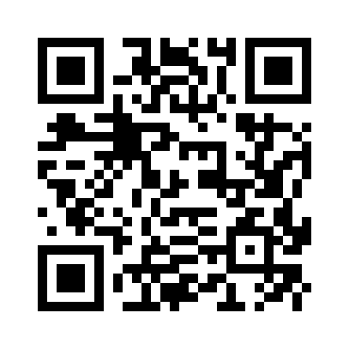 | FREE REGISTRATION  Register online: https://ndfbd.org/july  NDF | 01624-262148 | nationaldoctorsforum@gmail.com

2. PURPOSE AND STRATEGIC OBJECTIVES
The conference is designed to convert frontline experience into credible learning, historical documentation and practical recommendations for future health emergencies.
• Document the role of doctors, nurses, medical technologists, students, volunteers and allied health professionals.
• Identify clinical, ethical, logistical and public-health lessons from emergency response.
• Create an evidence-based platform for research, policy dialogue, witness sharing and humanitarian documentation.
• Develop recommendations for mass-casualty readiness, trauma systems, rehabilitation, mental health and institutional coordination.
• Build a verified academic and archival resource for future generations.
3. PROGRAMME FORMAT AND KEY COMPONENTS
COMPONENT | DETAILS
Opening Keynote | Healthcare leadership, humanitarian duty and public trust during national emergencies.
Scientific Oral Session | Peer-screened papers and structured presentations with moderated questions and feedback.
Poster / Visual Abstract Session | Concise academic displays for research, response analysis, policy proposals and documented case experiences.
Witness Sharing | Time-limited, ethically moderated testimony by frontline professionals and relevant stakeholders.
Expert Panel | Trauma, emergency surgery, rehabilitation, mental health, documentation, law, ethics and system preparedness.
Proceedings and Recommendations | Conference summary, selected publications and actionable recommendations for institutions and policymakers.
4. ELIGIBILITY
Doctors, surgeons, residents, medical and dental students, nurses, medical technologists, allied health professionals, public health professionals, researchers, academicians, administrators, humanitarian workers and healthcare families may register. Academic contributors must select an appropriate submission category.
5. HOW TO PARTICIPATE
1 | Open https://ndfbd.org/july and choose “July Medical Conference 2026”.
2 | Complete the free delegate registration form with accurate professional and institutional information.
3 | Select Delegate, Oral Paper, Poster, Witness Sharing, Policy Discussion, Memoir or Humanitarian Documentation as applicable.
4 | Upload the abstract or manuscript with author details, affiliations, keywords and correspondence information.
5 | Retain confirmation and follow the Scientific Committee’s instructions for presentation format and event-day reporting.

6. THEMATIC FOCUS AREAS
The conference will prioritise the following key contributions of healthcare professionals during the July Movement 2024:
1. Emergency Medical Response | 2. Humanitarian and Ethical Commitment
3. Mental Health Support, PTSD Awareness and Rehabilitation | 4. Documentation and Evidence Preservation
5. Public Health Advocacy | 6. Role of Medical Students and Young Professionals
7. SUBMISSION GUIDELINES
A. Call for Articles
PARAMETER | REQUIREMENT
Type of Submission | Full research / analytical article (original and unpublished)
Word Limit | Maximum 8,000 words including references and footnotes
Abstract | 250-300 words with 3-5 keywords
Citation Style | Oxford Footnote System
Formatting | Times New Roman, 12 pt, 1.5 line spacing, justified
File Format | Microsoft Word (.doc or .docx); no PDF for initial review
Language | English
Author Information | Brief bio (maximum 100 words), affiliation and contact details
B. Abstract / Poster Submission
Abstract and Poster Requirements
Word count: 400-500 words | Format: JPEG / PNG / PDF | Poster size: 36 x 18 inch (portrait) | Resolution: 300 DPI | Final submission deadline: 15 July 2026, 11:59 PM.
8. RULES, ETHICS AND CODE OF CONDUCT
• Registration is free; attendance and presentation slots remain subject to confirmation and venue capacity.
• Plagiarism, fabricated information, unverifiable claims and unauthorised images are not acceptable.
• Contributors must disclose conflicts of interest, funding, prior publication and use of AI-assisted tools where relevant.
• Patient information, sensitive images and witness identities require consent and responsible anonymisation.
• Presentations must remain within the assigned time and follow the official template.
• Respectful, non-defamatory and evidence-based communication is required throughout the conference.

9. SELECTION AND EVALUATION FRAMEWORK
CRITERION | WHAT THE REVIEW PANEL WILL CONSIDER
Relevance | Direct contribution to the conference theme and clear value for healthcare, humanitarian service or policy.
Scientific or Analytical Quality | Sound methods, coherent reasoning, appropriate evidence and transparent limitations.
Originality and Learning Value | New insight, credible documentation or practical lessons that extend current understanding.
Ethics and Accuracy | Consent, confidentiality, factual integrity, proper referencing and responsible use of sensitive material.
Presentation Quality | Clarity, structure, timing, visual quality and ability to respond to questions.
10. PRIZES AND RECOGNITION
AWARD / RECOGNITION | PROPOSED PACKAGE
Best Scientific Paper | Cash award or approved gift, crest, certificate and publication priority, subject to final approval.
Best Oral Presentation | Crest, certificate and special conference recognition.
Best Poster / Visual Abstract | Crest, certificate and display in the official knowledge archive.
Outstanding Humanitarian Documentation | Special recognition for a verified and ethically presented account or archive contribution.
All Selected Contributors | Presentation or contribution certificate and possible inclusion in proceedings, souvenir or digital archive.
11. SCHEDULE, ACCESS AND PARTICIPANT SUPPORT
• Conference desk opens before the academic session for badge collection and presentation verification.
• Final submission deadline, acceptance notice, presentation duration and templates will be announced on the official portal.
• Basic audio-visual support will be available; presenters should carry a backup copy of their file.
• Accessibility, emergency support and media permissions will be managed by the Organizing Committee.
Important Notice
The Organizing Authority reserves the right to revise, modify, postpone, cancel, or make any necessary decision regarding the programme, if circumstances require.
REGISTRATION
Register online: https://ndfbd.org/july
National Doctors Forum (NDF) | 01624-262148 | nationaldoctorsforum@gmail.com

12. JULY MEDICAL CONFERENCE SUB-COMMITTEE
NAME | CONTACT
Dr. Shoaib Momen Mojumder | 01708-524152
Dr. Nahiduzzaman Sazzad | 01914-332197
Dr. Habibur Rahman | 01834-208767
Official Event Artwork / Communication Visual
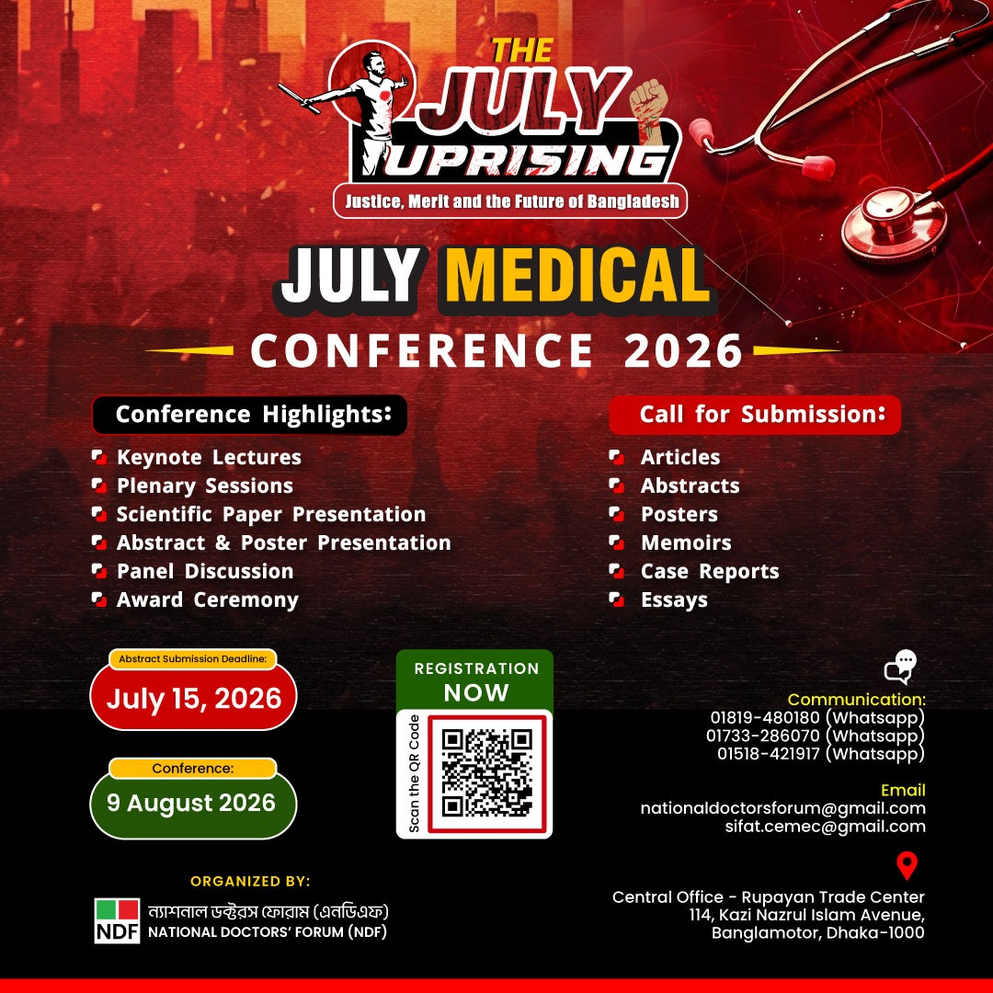
This event brief is prepared as an editable international-standard document for official communication, website upload and departmental coordination.

